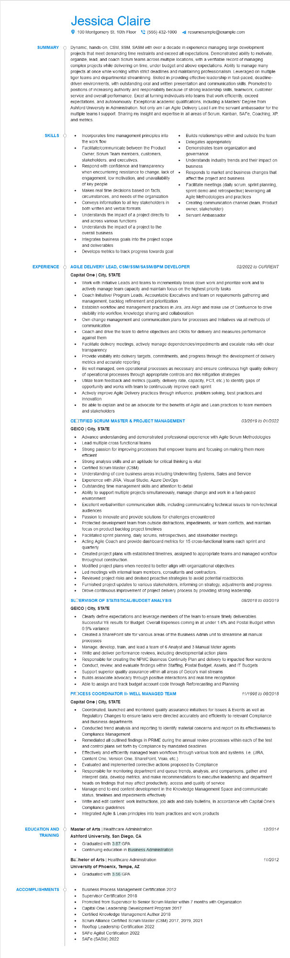
SUMMARY
Jessica Claire
100 Montgomery St. 10th Floor (555) 432-1000
resumesample@example.com
Dynamic, hands-on, CSM, SSM, SASM with over a decade in experience managing large development projects that meet demanding time restraints and exceed all expectations. Demonstrated ability to motivate, organize, lead, and coach Scrum teams across multiple locations, with verifiable record of managing complex projects while delivering on time, under budget and above expectations. Ability to manage many projects at once while working within strict deadlines and maintaining professionalism. Leveraged on multiple tiger teams and departmental streamlining. Skilled in providing effective leadership in fast-paced, deadline- driven environments, with outstanding oral and written presentation and communication skills. Promoted to positions of increasing authority and responsibility because of strong leadership skills, teamwork, customer service and overall performance. Excel at turning individuals into teams that work efficiently, exceed expectations, and autonomously. Exceptional academic qualifications, including a Masters' Degree from Ashford University in Administration. Not only am I an Agile Delivery Lead I am the servant ambassador for the multiple teams I support. Sharing my insight and expertise in all areas of Scrum, Kanban, SAFe, Coaching, XP, and metrics.
SKILLS
Incorporates time management principles into the work flow
Facilitate/communicate between the Product Owner, Scrum Team members, customers, stakeholders, and executives.
Respond with confidence and transparency
when encountering resistance to change, lack of engagement, low motivation, and unavailability of key people
Makes real time decisions based on facts, circumstances, and needs of the organization Conveys information to all key stakeholders in both written and verbal formats
Understands the impact of a project directly to and across various functions
Understands the impact of a project to the
overall business
Integrates business goals into the project scope and deliverables
Develops metrics to track progress towards goal
•
•
Builds relationships within and outside the team Delegates appropriately
Demonstrates team organization and
governance
Understands industry trends and their impact on business
Responds to market and business changes that
affect the project and business
Facilitate meetings (daily scrum, sprint planning,
sprint demo and retrospective) leveraging all Agile Methodologies and practices
Creating communication channel (team, Product owner, stakeholder)
• Servant Ambassador
EXPERIENCE Ó AGILE DELIVERY LEAD, CSM/SSM/SASM/BPM DEVELOPER
Capital One | City, STATE
•
•
•
•
02/2022 to CURRENT
Work with Initiative Leads and teams to incrementally break down work and prioritize work and to actively manage team capacity and maintain focus on the highest priority tasks
Coach Initiative/ Program Leads, Accountable Executives and team on requirements gathering and management, backlog refinement and prioritization
Establish workflow and management practices in Jira, Jira Align and make use of Confluence to drive visibility into workflow, knowledge sharing and collaboration
Own change management and communication plans for processes and Initiatives via all methods of communication
Coach and drive the team to define objectives and OKRS for delivery and measures performance against them
Facilitate delivery meetings, actively manage dependencies/impediments and escalate risks with clear transparency
Provide visibility into delivery targets, commitments, and progress through the development of delivery metrics and accurate reporting
Be well managed, own operational processes as necessary and ensure continuous high quality delivery
of operational processes through appropriate controls and risk mitigation strategies
Utilize team feedback and metrics (quality, delivery rate, capacity, FCT, etc.) to identify gaps of opportunity and works with team to continuously improve each sprint
Actively improve Agile Delivery practices through influence, problem solving, best practices, and innovation
Be able to explain and be an advocate for the benefits of Agile and Lean practices to team members and stakeholders
CERTIFIED SCRUM MASTER & PROJECT MANAGEMENT
GEICO | City, STATE
•
03/2019 to 01/2022
Advance understanding and demonstrated professional experience with Agile Scrum Methodologies Lead multiple cross functional teams
• Strong passion for improving processes that empower teams and focusing on making them more efficient
• Strong analysis skills and an aptitude for critical thinking is vital
Certified Scrum Master (CSM)
•
Understanding of core business areas including Underwriting Systems, Sales and Service
Experience with JIRA, Visual Studio, Azure DevOps
•
Outstanding time management skills and attention to detail
Ability to support multiple projects simultaneously, manage change and work in a fast-paced environment
Excellent verbal/written communication skills, including communicating technical issues to non-technical audiences
Passion to innovate and provide solutions for challenges encountered
Protected development team from outside distractions, impediments, or team conflicts, and maintain focus on product backlog project timelines
Facilitated sprint planning, daily scrums, retrospectives, and stakeholder meetings
Acting Agile Coach and provide dashboard metrics for 15 cross-functional teams each sprint and
quarterly
Created project plans with established timelines, assigned to appropriate teams and managed workflow throughout construction.
Modified project plans when needed to better align with organizational objectives.
Led meetings with internal team members, consultants and contractors.
•
Reviewed project risks and devised proactive strategies to avoid potential roadblocks.
•
Furnished project updates to various stakeholders, informing on strategy, adjustments and progress. Drove continuous improvement of project delivery process by providing strong leadership. SLOERVISOR OF STATISTICAL/BUDGET ANALYSIS
GEICO | City, STATE
08/2018 to 03/2019
Clearly define expectations and leverage members of the team to ensure timely deliverables. Successful YE results for Budget: Overall Expenses coming in at under 1.6% and Postal Budget within 0.9% variance
Created a SharePoint site for various areas of the Business Admin unit to streamline all manual processes
Manage, develop, train, and lead a team of 6 Analyst and
Manual Meter agents
Write and deliver performance reviews, including developmental action plans
Responsible for creating the NPMC Business Continuity Plan and delivery to impacted floor wardens
•
Conduct, review, and evaluate findings within Staffing, Postal Budget, Assets, and IT Budgets
• Support superior quality assurance within all areas of Geico's mail streams
• Builds associate advocacy through positive interactions and real-time recognition
• Able to assign and track budget account code through Reforecasting and Planning
PROCESS COORDINATOR II- WELL MANAGED TEAM
Capital One | City, STATE
11/1998 to 08/2018
Coordinated, launched and monitored quality assurance initiatives for Issues & Events as well as Regulatory Changes to ensure tasks were directed accurately and efficiently to relevant Compliance and Business departments
Conducted trend analysis and reporting to identify material concerns and report on its effectiveness to Compliance Management
Remediated all outlined findings in PRIME during the annual review processes within each of the test and control plans set forth by Compliance by mandated deadlines
Effectively and efficiently managed team workflows through various tools and systems. i.e. (JIRA, Content One, Version One, SharePoint, Visio, etc.)
Evaluated and implemented corrective actions proposed by Compliance
•
Responsible for monitoring department and queue trends, analysis, and comparisons, gather and
interpret data, develop metrics, and make recommendations to executive leadership and department heads on findings that may affect productivity, access and quality of service
Manage end to end content development in the Knowledge Management Space and communicate status, timelines and impediments effectively
Write and edit content: work instructions, job aids and daily bulletins, in accordance with Capital One's Compliance guidelines
Integrated Agile & Lean principles into team practices and work products
EDUCATION AND TRAINING
Master of Arts | Healthcare Administration
Ashford University, San Diego, CA
• Graduated with 3.87 GPA
Continuing education in Business Administration
Bachelor of Arts | Healthcare Administration
University of Phoenix, Tempe, AZ
•
Graduated with 3.56 GPA
ACCOMPLISHMENTS
•
Business Process Management Certification 2012
Supervisor Certification 2018
Promoted from Supervisor to Senior Scrum Master within 7 months with Organization
Certified Knowledge Management Author 2018
•
Capital One Leadership Development Program 2017
•
Scrum Alliance Certified Scrum Master (CSM) 2017, 2019, 2021
SAFe Agilist Certification 2022
Rooftop Leadership Certification 2022
SAFE (SASM) 2022
12/2014
11/2012

